Adding Board Support for ESP32 in Arduino IDE
- Install and Open latest version of and go to File > Preferences.
- Copy and paste the following URL in the “Additional Board Manager URLs” field.

https://dl.espressif.com/dl/package_esp32_index.json

- Press OK and exit from the Preferences Menu.
- Now navigate to Tools > Board > Boards Manager as shown in the figure below

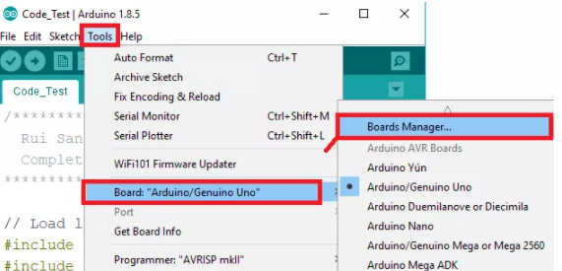

- Let the Boards Manager initialize and then type “ESP32” in the search bar.
- The ESP32 Board Support will appear in the option below as shown.

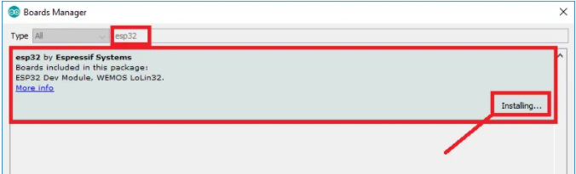

- Choose the install button to and let it install. ESP32 Board Support will then be added to your list of supported boards.
- Before uploading, you need to select “ESP32 Dev Module” from the list of available boards in Tools > Boards.
- You will then be able to upload code to an ESP32 Development Kit.
- Now open the shared firmware files and select “first-babak_with_timestamp.ino” file and open it.
- Select “ESP32 Dev Module” from list of boards and then proceed to connect your ESP32 Development Kit to the system via USB – Micro-USB Cable.
- The ESP32 Development Kit will appear on one of the COM Ports on the system. Select the correct COM Port from “Tools > Port” menu and proceed to press the upload button on the Arduino.
- The program will compile and then be uploaded onto the ESP32 Development Kit.
- Open Serial Monitor by pressing “Ctrl+Shift+M” combination for debugging information.
- Make sure to connect all the sensors on the mentioned pins before powering the ESP32 Development Kit.

